Buddy Bench Page 1 of 2

[Link to Ordering form TreeTop Products-The Bench FACTORY](https://www.thebenchfactory.com/buddy-bench-for-little-buddies?sku=2ZK2407-TN/BL/RD&msclkid=a5e767ab2fe111d9102801e87d3495a9&utm_source=bing&utm_medium=cpc&utm_campaign=TBF%20Shopping&utm_term=1100908970156&utm_content=TBF%20Shopping)   
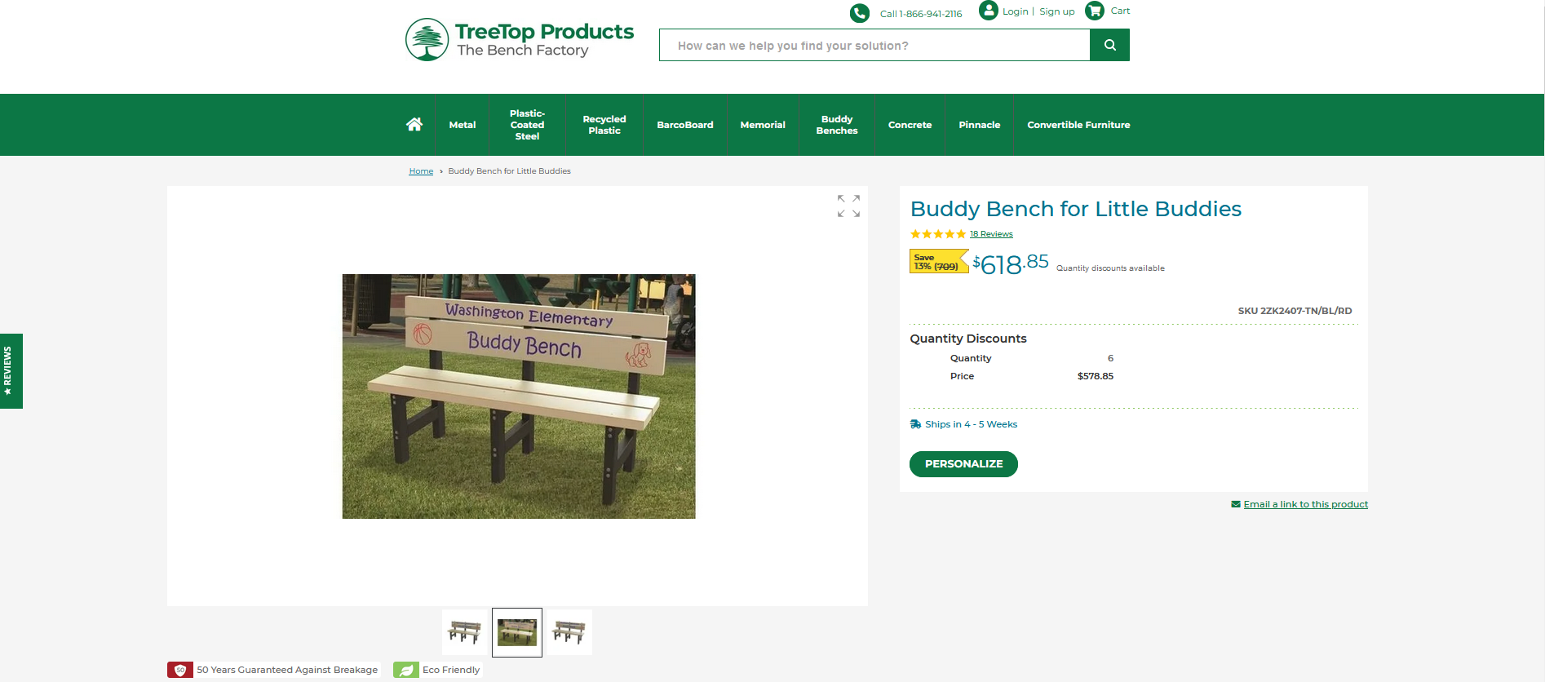

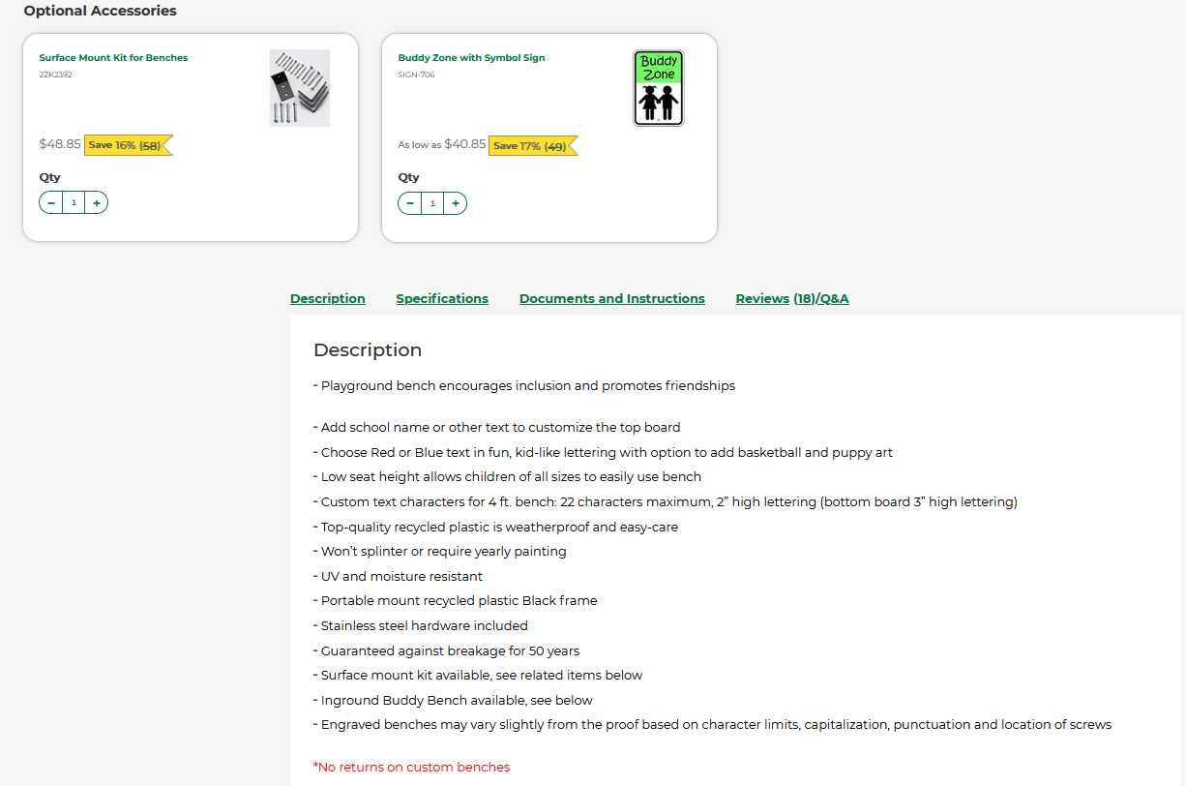

Buddy Bench Page 2 of 2

